Noah Smith

CIS 310-02

9/4/2019

Week 3 Homework

21. Employee number is the primary key due to the fact that it is the first column and since each record has its own unique id. Job code is most likely a foreign key. This makes since because it would fit the conventions. None of the other columns appear to be a foreign key.

22. In the Director table DIR_NUM is the primary key and on the Play table PLAY_CODE is the primary key.

23. The Director table doesn’t appear to have a foreign key. The DIR_NUM column on the Play table is the foreign key and it comes from the Director table.

24.

25.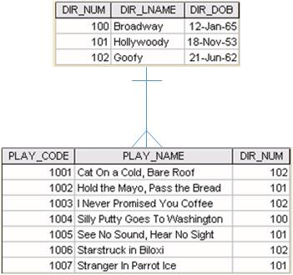

26. you would use the Play table and use the DIR_NUM column as the index and join it with the Director table off the DIR_NUM. Once this is done the user should be able to select all plays where the Director number equals a given value.

27. SELECT * FROM PLAY p

WHERE p.DIR_NUM = @DIR_NUM

This would select all of the rows from PLAY where the DIR_NUM would equal the DIR_NUM given.